**Final Project Report**

**Pharmacy Workflow Transformation System**

**Sensible Seven Solutions**

**November 26, 2015**

## **Table of Contents**

Table of Contents

Revision History

1.0 Introduction

1.1 Project Overview

1.1.1 Executive Summary

1.1.2 Context

1.1.3 Need

1.1.4 Scope

1.1.5 Stakeholders

1.1.6 Objectives

1.2. Project Approach

1.2.1 Milestones

1.2.2 Work Breakdown Structure

1.2.3 Deliverables

1.2.4 Risks

2.0 Requirements

2.1 Use Cases

2.1.1 Use Case Diagram

2.1.2 Use Case Descriptions

2.2 Domain Model

2.2.1 Entity Relationship Diagram

2.2.2 Dataflow Diagrams

2.3 Functional Requirements and System Features

2.3.1 Immunizations

2.3.1.1 - Description and Priority

2.3.1.2 - Stimulus/Response Sequences

2.3.1.3 - Functional Requirements

2.3.2 Prescriptions

2.3.2.1 - Description and Priority

2.3.2.2 - Stimulus/Response Sequences

2.3.2.3 - Functional Requirements

2.3.3 General Sales

2.3.3.1 - Description and Priority

2.3.3.2 - Stimulus/Response Sequences

2.3.3.3 - Functional Requirements

2.4 Non-Functional Requirements

2.4.1 Performance Requirements

2.4.2 Safety Requirements

2.4.3 Security Requirements

2.4.3 Software Quality Attributes

3.0 Solution

3.1 Design

3.2 Storyboards

3.3 Sequence Diagrams

4.0 Conclusion & Recommendations

4.1 Reflection on experience

4.2 Recommendation for future students

5.0 Contributions

6.0 Appendices

A. Glossary

B. Interview Notes

i) First Client Meeting

ii) Second Client Meeting

C. Miscellaneous Materials

## **Revision History**

|  |  |  |  |
| --- | --- | --- | --- |
| **Name** | **Date** | **Reason for Changes** | **Version** |
| Sensible Seven Solutions | Nov. 19th | Document creation | 1.0 |
| Sensible Seven Solutions | Nov. 23rd | Document updating | 1.1 |
| Sensible Seven Solutions | Nov. 26th | Final Revisions | 2.0 |

# **1.0 Introduction**

## **1.1 Project Overview**

### **1.1.1 Executive Summary**

This project, *Pharmacy Workflow Transformation*, aims to improve customer satisfaction at UVCP through shorter wait times and more reliable immunization services as well as reduce the occurrence of staff being overwhelmed.

This project charter aims to provide a preliminary overview of the project and ensure a mutual understanding on all major aspects of the project. The primary objective of the project is to increase customer satisfaction at UVCP by ensuring the availability of immunization services. UVCP is currently faced with the problem of not being able to provide efficient immunization to customers during high-traffic periods. The scope of the project includes building a booking system. Developing a notification system for clients is outside of the project’s scope. The stakeholders include pharmacy customers, staff, and the University itself. By December 3rd, the final report will be submitted and solution presented. An estimated cost of the project’s solution is not yet determined, however the client organization’s budget is $10,000. Key deliverables include the project charter pitch presentation, project requirements, and the final project report.

### **1.1.2 Context**

UVCP, a location of Heart Pharmacy, provides various services including prescription filling, vaccinations, and miscellaneous sales. The pharmacy is sometimes unable to readily provide immunization services to customers during peak hours, resulting in customer dissatisfaction or loss. Heart Pharmacy has multiple locations throughout Victoria, but is currently only facing these problems at the UVic location. The current staff at this location consists of a pharmacy technician and a pharmacist who share access to a single computer. The small physical space makes hiring additional employees an unrealistic solution.

### **1.1.3 Need**

UVCP is unable to effectively provide immunization services to its clients during high traffic periods. This is due to immunization services being provided on a walk-in basis, it is difficult to predict when these “high traffic” situations will occur. The other two services, filling prescriptions and general sales, take priority over immunizations. There is no current system to provide scheduling for immunizations at UVCP and the office itself consists of a single computer near the drop-off counter, primarily used to check customer health coverage. This current system is inadequate because the congestion during high traffic situations often leaves patients unhappy and inconvenienced by the long waiting times.

### **1.1.4 Scope**

What is inside or outside of the scope of the project could be listed ad infinitum. The following examples should provide a clear sense of project’s boundaries. .Note that “system” refers to the future solution for which the requirement outlined in this document will address.

In scope:

Our group is going to research the current campus pharmacy working system in order to identify any weaknesses and gain an understanding of the current system. Our group is going to come up with a prototype solution based on the identified weaknesses to help the current system to improve their immunization services. Our group will meet back with the clients in order to get feedback on the proposed solution. Our group finally is going to revise the final solution based on the feedback.

Out of scope:

Things that are outside the scope of the project include changing the current workflow of the pharmacy, changing the amount of employees or adding additional devices, and cooperating with other pharmacies.

### **1.1.5 Stakeholders**

The stakeholders of this project include the customers of UVCP, which consists of UVic students and faculty, and the general public. These customers are the primary targets of the system and may also be direct users of the system, such as in an online scheduling system. The pharmacy staff are stakeholders as their business operations will be directly affected by the success of this system. They are responsible for influencing and approving the project and its deliverables to meet their needs. The University of Victoria is also a stakeholder as their interests may be affected by the execution of this project. Depending on the system, they may or may not have direct involvement with the project. For example, a web-based solution may be hosted on UVic’s website.

### **1.1.6 Objectives**

The general need of the project is to affect the current workflow to improve customer experience by ensuring the availability of immunization services. However, the current system is not able to provide such reliable services. The objectives of the project are to address the following problems; the current system is:

* Not able to effectively provide immunization services to its clients during high traffic periods.
* Does not provide scheduling for patients who want to get immunizations services at UVCP.
* Inadequate because the congestion during high traffic situations often leaves patients unhappy and inconvenienced by the long waiting times.

## **1.2. Project Approach**

### **1.2.1 Milestones**

|  |  |  |
| --- | --- | --- |
| **Project Milestone** | **Description** | **Date** |
| Phase One - Requirements Gathering & Documenting | First meeting with the client and documenting of requirements for an immunization system for Heart Pharmacy. | October 16, 2015 |
| Phase Two - Design & Prototyping | Analysis of requirements and mock up of suggested solution completed and shown to Heart Pharmacy during second client meeting for feedback. | November 12, 2015 |
| Phase Three - Final Client Presentation and Report | Present final solution to class and submit final report. | December 3, 2015 |

### **1.2.2 Work Breakdown Structure**

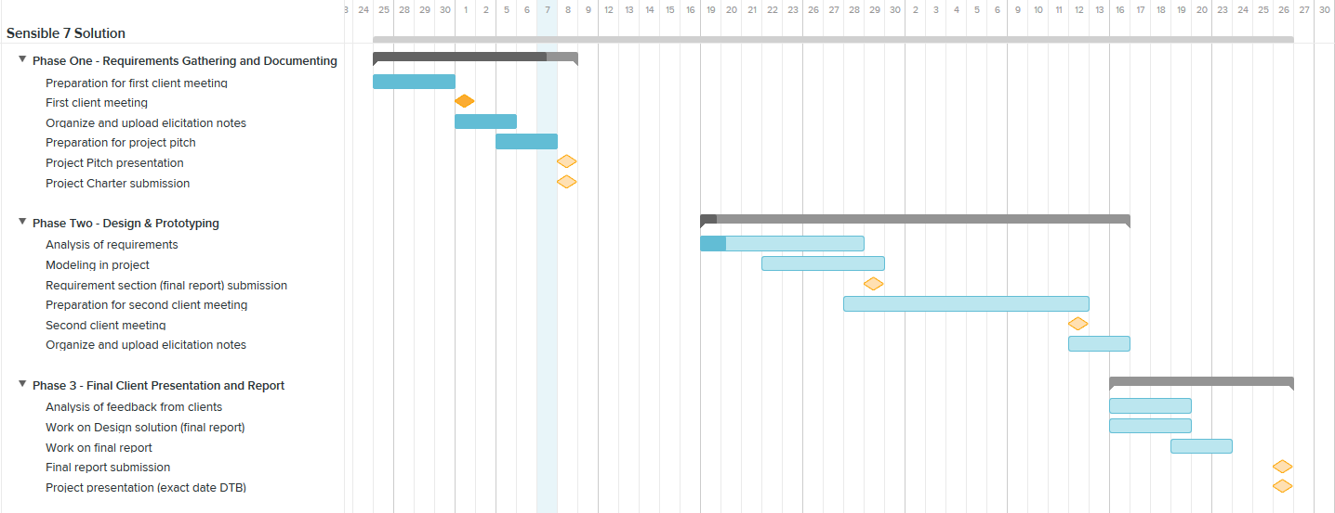

### **1.2.3 Deliverables**

The following is a list of all the deliverables for this project:

* Request for Proposal - Completed on September 24th of 215.
* Project Charter - To be completed by October 8th of 2015.
  + Document created towards presenting the problem within the organization. Describes various important points that must be taken into serious consideration including including stakeholders, needs, goals, risks, and more.
* Project Charter Pitch Presentation - To be completed by October 8th of 2015.
  + The main points of the project charter are presented through a presentation.Through this presentation, various points from the charter are emphasized upon, points that must be taken into serious consideration.
* Project Requirements - To be completed by October 28th of 2015.
  + Describes and explains the various required procedures, and activities that the suggested solution is expected to meet. Requirements must be clearly stated in ensuring that all requirements are met.
* Final Project Report - To be completed by November 26th of 2015.
  + Document created that includes all documents created thus far relating to solving the organization's problem. This document includes the solutions, charter, RFP, project requirements and future work.
* Final Presentation - To be completed by November 26th of 2015.
  + This presentation describes the main points of the final project report. Main points include the problem at hand, how the problem was solved, and possible problems encountered.

### **1.2.4 Risks**

|  |  |  |  |  |
| --- | --- | --- | --- | --- |
| **No.** | **Description** | **Probability**  **(H/M/L)** | **Effect**  **(H/M/L)** | **Planned** **Mitigation** |
| 1.Cost | There are cost risks associated with all projects. This project does not have the biggest budget, and potentially going over the budget could be a major risk. | H | H | We will do a deep financial analysis before we start our project and also provide a realistic budget report. |
| 2. Shut down system for upgrade. | Systems require updates time to time, and occasionally updates cause delays in the system. These delays could potentially cause customers to feel more frustration and dissatisfaction. | M | H | We will post a message to indicate we are going to shut down the system. This message will be posting at 24 hours before maintenance and we will ensure that the maintenance will not take place during the rush hour. |
| 3. System crash | Systems are not perfect, they do crash occasionally. These system crashes occur at unexpected times and need to be taken into consideration. | L | H | Our system will have a feature to detect system crash. This feature will automatically tell our technicians and provide users with another alternative ways to use our service. However if this feature also fails, we will arrange to have a technician team available to us 24/7 to repair the systems within a short time period. |
| 4. Ineffective training of new system. | With a new system being implemented, there is always a risk of ineffective training being associated. Employees not being able to use a system to its fullest potential due to ineffective training will cause more delays within their practice. | M | M | We will provide very specific written instruction on the system. We will also offer training for employees before they work. Lastly, we will offer a online tutorial, where first hand users can go and learn the system from the comfort of their home before their shift begins. |
| 5. Difficulties adapting to change. | With a new solution, comes new changes to an organization's practice. This is associated with the risk of employees and other stakeholders within the organization not being open to changing their organization's culture. | M | L | Inform users and stakeholders about the benefit of the new system by comparing new system with old system. Also, help first hand users slowly progress into using the new system comfortably, through effective training. |

# **2.0 Requirements**

## **2.1 Use Cases**

### **2.1.1 Use Case Diagram**

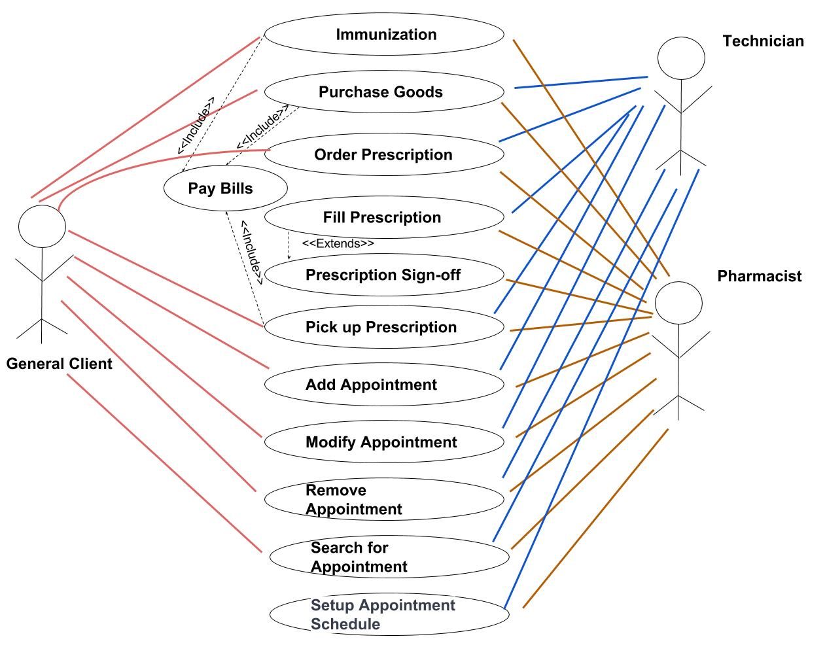

Additional use cases add appointment, modify appointment, remove appointment,search for appointment, and setup appointment schedule were added to outline how the new software will be used.

### **2.1.2 Use Case Descriptions**

**Immunization**

Actors: General Client, Staff (Pharmacist or Pharmacy Technician)

Preconditions:

* The requested immunization is available at the pharmacy
* General Client has no known allergies to the vaccine components

Main Flow:

1. General Client arrives at pharmacy
2. General Client requests an immunization from staff at the counter
3. General Client presents patient information to the staff at the counter
4. Staff at counter checks for patient records on computer
5. Staff at counter gives the general client an estimated wait time
6. General Client waits until the Pharmacist is available to see them
7. The Pharmacist educates the Customer on the immunization and administers it
8. The General Client waits in the pharmacy for 15 minutes to ensure there are no bad side-effects.
9. Go to “Pay Bill” use case

Alternate Flow:

1. **General Client is not in the Pharmacy database**

At step 4, if the general client is not in the pharmacy database:

1. Staff will add a patient record of the general client into the database.
2. **General Client begins showing unwanted side-effects to the immunization**

In the case of a general client reacting negatively to the immunization and unwanted side effects showing after step 7:

1. Staff will contact emergency services
2. The General Client will be accessed and treated by medical staff who may or may not transport the General Client to the hospital.

**Purchase Goods**

Actors: General Client, staff (Pharmacist or Pharmacy Technician)

Preconditions:

* The cash register and scanner is working

Main flow:

1. General Client arrives at pharmacy
2. General Client locates and picks up merchandise
3. General Client presents the merchandise to staff working the counter
4. Go to “Pay Bill” use case

Alternative flow

1. **Item cannot be found by General Client**

If in step 2 in the main flow, the general client cannot find the merchandise that he/she is looking for:

1. Staff comes up to help the general client with finding the merchandise
2. Resumes at step 3
3. **Item is currently unavailable**

If in step 2 in the main flow, the general client cannot find the merchandise that he/she is looking for:

1. Staff comes up to help the general client with finding the merchandise
2. Merchandise cannot be found and therefore cannot be provided for sale
3. General Client leaves pharmacy or resumes at step 3 if purchasing other merchandise

**Pay Bill**

Actors: General client and staff (pharmacist or pharmacy technician)

Preconditions:

* The Immunization, Purchase Goods, or Prescription Pick up use case has been completed
* The cash register is working
* The credit card machine is connected to the network
* There are sufficient paper for receipt printing in the cash register and credit card machine
* There are sufficient cash and coins for change in the cash register

Main Flow:

1. Staff enters item price(s) into cash register
2. Staff tells the general client the total owing
3. General client chooses to pay by cash, debit, or credit card
4. General client hands over the cash or inserts debit/credit card into the credit card machine
5. If paying by card, general client confirms the amount and enters the pin
6. Staff prints off the receipt
7. General client receives the receipt

Alternative Flow:

1. **Prescription or immunization is fully covered by the general client’s health insurance**

If in step 1 of the main flow the general client is only paying for prescription(s) and/or immunization(s) that are fully covered by their health plan

* 1. general client does not need to pay upfront, skip to step 6 of the main flow

1. **General Client have insufficient amount of payment**

If in step 2 of the main flow, the general client have insufficient balance on his/her card:

1. General client choose another payment method and resumes at step 2
2. General client does not want the merchandise anymore
3. **The chip is not working on the card**

If in step 2 of the main flow, the chip on the credit card is not working

1. General client swipes his/her card in the machine
2. General client confirms the amount
3. General client signs the receipt for validation
4. Resumes at step 4

**4. The general client is paying by fake bills**

If in step 2 of the main flow, the general client is paying by fake bills

1. General client choose another payment method and resumes at step 3
2. General client does not want the merchandise anymore

**Order Prescription**

Actors: General clients and staff (pharmacist or pharmacy technician)

Preconditions:

* General client provides pharmacist or pharmacy technician with a prescription from a doctor.

Main Flow:

1. Staff receives prescription from general client
2. Staff looks up general client information in the pharmacy database
3. Staff verifies prescription
4. Staff provides general client with wait time
5. Staff creates prescription order
6. Go to “Fill Prescription” use case

Alternative Flow:

1. **General client can not be found in the system**
2. Staff will create a new record for this general client.
3. resume at step 3
4. **The prescription doesn’t pass the staff’s verification**
5. Staff will ask the general client to take the prescription back to the doctor.

**Fill Prescription**

Actors: Staff (pharmacist or pharmacy technician)

Preconditions:

* The “Order Prescription” use case has been completed

Main Flow:

1. Staff reviews the prescription order
2. Staff finds the medication in the inventory
3. Staff dispenses medication
4. Staff affixes labels to exterior of prescription container
5. Go to “Pick Up Prescription” use case if Pharmacist completed previous steps or otherwise go to “Prescription Sign-off” use case.

Alternative flow:

1. **The medication can not be found in the inventory**
2. Staff adds medication to next order
3. Staff contacts another pharmacy to purchase a small supply; enough to fulfill prescription
4. resumes at step 3
5. **There is not enough medication in the inventory to fill prescription**
   1. Staff partially fills prescription
   2. Staff orders more of the medication
   3. resumes at step 4
6. **Uncertainty if correct amount was dispensed**
   1. Staff re-dispenses medication
   2. resumes at step 4
7. **Prescription label gets damaged**
   1. Staff reprints label
   2. resumes at step 4

**Prescription Sign-off**

Actors: Pharmacist

Preconditions:

* The Fill Prescription use case was completed by the pharmacy technician

Main flow:

1. Pharmacist verifies the medication dispensed matches the prescription order
2. Pharmacist initials prescription order

Alternative flow

1. **Dispensed medication does not match prescribed medication**
   1. Return medication to inventory and redo “Fill Prescription” use case

**Prescription Pick-up**

Actors: General Client, Staff (Pharmacist or Pharmacy Technician)

Preconditions:

* The “Fill Prescription” use case was completed by the Pharmacist or the “Prescription Sign-off” use case was completed if “Fill Prescription” use case was completed by the Pharmacy Technician

Main flow:

1. Staff notify the waiting General Client that prescription is ready
2. Staff verifies with the General Client that they have taken the medication before
3. Go to “Pay Bill” use case

Alternative flow

1. **General client chose to pick up prescription at a later time and/or date**
   1. General Client arrives at prescription pick up counter
   2. General Client provides Staff with name
   3. Staff locates prescription
   4. resumes at step 2
2. **Prescription cannot be found**
   1. Staff verifies order was added to the system
   2. Staff reprints order
   3. Go to “Fulfill Prescription” use case
3. **General Client has not taken the medication before**
   1. Pharmacist educates the General Client about the prescribed medication
   2. Go to “Pay Bill” use case

**Add Appointment**

Actors: Patient, Staff (Pharmacy, Pharmacy Technician)

Preconditions:

* Patient has requested an immunization via walk-in and the Pharmacist is unavailable to provide immunization within 10 minutes or patient has requested to book an immunization
* The computer is in working order

Main Flow:

1. Staff opens PASS (Pharmacy Appointment Scheduling Software)
2. Staff selects an available time slot suitable to the patient’s availability
3. Staff clicks on “***Add Appointment***” in the bottom left window pane
4. Staff enters patient name, phone number, email, name of immunization requested.
5. Staff clicks on “***Save***”

Alternate Flow

1. PASS fails to open
   1. Staff restarts computer and resumes at step 1
2. No response when selecting “***Add Appointment***”
   1. Staff restarts PASS and resumes at step 2
3. Immunization requested needs a longer time slot
   1. While executing step 4, Staff increase appointment duration time and resumes at step 5
4. Appointment fails to save
   1. Staff reattempts creating the appointment resuming at step 2
   2. Staff restarts PASS and resumes at step 2
   3. Staff restarts computer and resumes at step 1

**Modify Appointment**

Actors: Patient, Staff (Pharmacy, Pharmacy Technician)

Preconditions:

* Patient has requested to change their pre-existing appointment
* Pharmacy computer is in operational order
* “Add Appointment” use case has been completed

Main Flow:

1. Staff opens PASS
2. Staff selects appointment to be modified in the calendar
3. Staff clicks on “***Edit Appointment***” in the bottom left window pane
4. Staff updates appointment time to a new available time for both patient and pharmacist, patient’s phone number or email, or name of immunization requested
5. Staff clicks on “***Done***”

Alternate Flow

1. PASS fails to open
   1. Staff restarts computer and resumes at step 1
2. Appointment to be modified cannot be found
   1. Staff confirms date and time with patient
   2. Staff recreates appointment using “Add Appointment” use case
3. No response when selecting “***Edit Appointment***”
   1. Staff restarts PASS and resumes at step 2
4. PASS fails to save changes
   1. Staff reattempts creating the appointment
   2. Staff restarts PASS and resumes at step 2
   3. Staff restarts computer and resumes at step 1

**Delete Appointment**

Actors: Patient, Staff (Pharmacy, Pharmacy Technician)

Preconditions:

* Patient has request to cancel or has not shown for their appointment
* Pharmacy computer is in operational order

Main Flow:

1. Staff opens PASS
2. Staff selects appointment to remove
3. Staff clicks on “***Delete Appointment***” in the bottom left window pane
4. Staff selects “***Delete***” on warning message popup window
5. Staff confirms correct appointment was removed

Alternate Flows:

1. PASS fails to open
   1. Staff restarts computer and resumes at step 1
2. Appointment to be removed cannot be found
   1. Staff confirms date and time with patient and resumes at step 5
3. No response from system after selecting “***Delete Appointment***”
   1. Staff restarts PASS and resumes at step 2
4. Wrong appointment is deleted
   1. Staff re-adds appointment that should not have been deleted using “Add Appointment” use case and resumes at step 2
5. Staff selects “***Return***” instead of confirm
   1. Staff resumes at step 2

**Search for Appointment**

Actors: Patient, Staff (Pharmacy, Pharmacy Technician)

Preconditions:

* Pharmacy computer is fully operational

Main Flow:

1. Staff opens PASS
2. Staff enters patient’s name in search bar
3. Staff selects a name from the search results

Alternate Flows:

1. PASS fails to open
   1. Staff restarts computer and resumes at step 1
2. Staff enters in wrong name, phone number or email
   1. Staff confirms correct information with Patient and resumes at step 2

**Setup Appointment Schedule**

Actors: Staff (Pharmacy, Pharmacy Technician)

Preconditions:

* Pharmacy computer is fully operational

Main Flow:

1. Staff opens PASS
2. Staff opens settings window by clicking on the settings icon
3. Staff enters time periods for each day that immunization appointments will be available
4. Staff clicks “***Save***”

Alternate Flows:

1. PASS fails to open
   1. Staff restarts computer and resumes at step 1
2. No response from system after clicking on the settings icon
   1. Staff restarts PASS and resumes at step 2
3. Availability does not save
   1. Staff attempts to re-enter availability resuming at step 2
   2. Staff restarts PASS and resumes at step 2
   3. Staff restarts computer and resumes at step 1

## **2.2 Domain Model**

### **2.2.1 Entity Relationship Diagram**

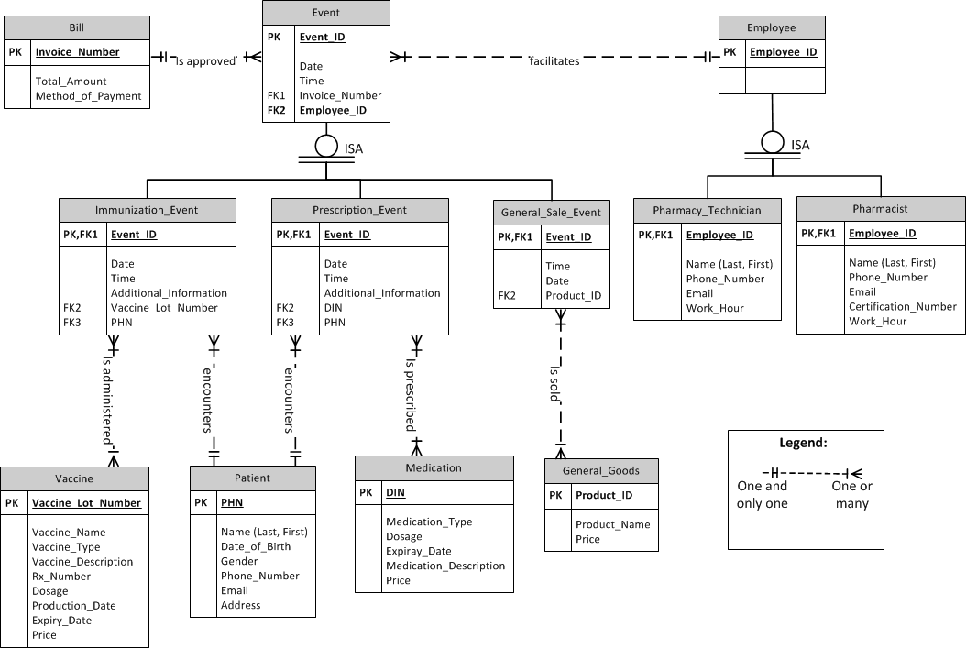

Note: A customer entity is not included in this diagram since it is assumed that there is not information recorded in the database if only general goods are being purchased.

### **2.2.2 Dataflow Diagrams**

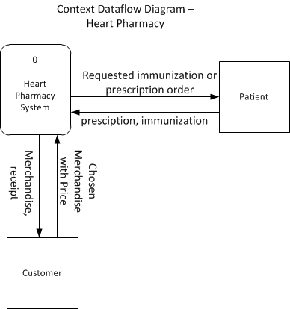

The pharmacist and pharmacy technician are not external entities outside of the Heart Pharmacy system because they are components of the system and not external to it.

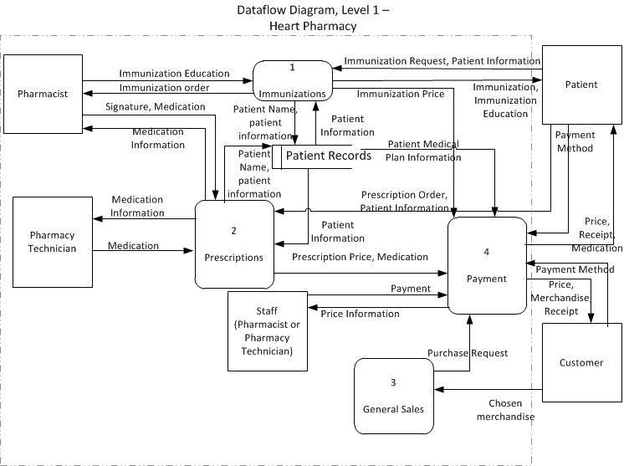

Patient information is flowing from both the patient and patient records data store. Patients can provide just their name and the rest of the information comes from the database. If the patient is new or has outdated information, more of the information will come from the patient so the pharmacist or technician can create or update the record.

## **2.3 Functional Requirements and System Features**

### **2.3.1 Immunizations**

#### 2.3.1.1 - Description and Priority

The immunization service is provided on a walk-in basis. The service consists of a vaccination, educating the client of the vaccination they are receiving, and a waiting period to check for any side effects. Immunizations must be administered by the pharmacist. This feature is a high priority of the system.

#### 2.3.1.2 - Stimulus/Response Sequences

- Customer requests immunization

- System responds with an estimated wait time (if any)

- Pharmacist administers vaccination to customer

#### 2.3.1.3 - Functional Requirements

REQ-1: The system shall be able to take in high volume of immunization requests that can be later approved by employees through examination of the client's medical history.

Backwards Traceability - During high traffic periods UVCP receives a highly abnormal and unexpected amount of immunization requests.

Forward Traceability - Test scenario to be performed with 8-10 simultaneous immunization requests that need to be approved.

REQ-2: The client will be able to schedule their immunization appointment in advance.

Backwards Traceability - The RFP states there are abnormally long wait times due to a high volume of walk-in patients.

Forward Traceability - The history of clients who have scheduled an appointment, and their immunization procedure was successfully completed at the requested time.

REQ-3: The system must be able to guide the pharmacist through the immunization process effectively and efficiently towards reducing wait time for other clients/customers.

Backwards Traceability - Immunization are taking up excessive amounts of time, however the pharmacist does not want to speed up the process to sacrifice quality as stated in the RFP.

Forward Traceability - Measured through questionnaires asking clients if the immunization process excluding wait time was completed within 20-30 minutes, and if it was performed accurately (no complications/errors) and to their satisfaction.

REQ-4: The new system must allow for every immunization to be recorded in an effective and efficient manner with specific detail of the procedure that was performed.

Backwards Traceability - Entering patient data for every procedure that occurs is very time consuming, and often times employee leaves it until the last minute during high traffic periods.

Forwards Traceability - Measured through a timed test scenario, where employees will be asked to record an immunization procedure within 1 minute, with a detailed description.

REQ-5: The system should emphasize to the pharmacist the importance of educating patients about their immunization, such as possible side effects, both before and after the immunization process.

Backwards Traceability - Often times employees forget to educate clients on certain procedures and possible side effects.

Forward Traceability - The employee must educate the client as the first step of the immunization procedure.

REQ-6: Creating and processing vaccine orders must be easily manageable through an organized ordering system for each client.

Backwards Traceability - Currently employees get confused about ordering vaccines as per the RFP.

Forward Traceability - Employees will be questioned about the levels of difficulties they experienced when creating and processing vaccine orders.

### **2.3.2 Prescriptions**

#### 2.3.2.1 - Description and Priority

Prescriptions are filled by either the pharmacist or the technician, but must be approved by the pharmacist. Similar to immunizations, this service is provided on a walk-in basis. The customer is charged based on the medication and/or their health coverage. This is a medium priority of the system.

#### 2.3.2.2 - Stimulus/Response Sequences

* Customer provides prescription to be filled
* Pharmacist or technician checks prescription
* Pharmacist or technician dispenses medication
* Pharmacist signs off on the prescription
* Customer is billed for the prescription

#### 2.3.2.3 - Functional Requirements

REQ-1: Software must be able to lookup customer’s health care coverage and other billing information.

Backwards Traceability - According to the RFP, employees are having difficulties looking up patients health care coverage through the outdated single computer.

Forward Traceability - Employees will be asked whether they were able to access customers health care coverage and other billing information.

REQ-2: The new system should provide approval or disapproval of requested prescriptions through effective examination of the client's history.

Backwards Traceability - No system is in place currently that examines client's history to identify if they are suited for the prescription prescribed as learned in the first client meeting.

Forward Traceability - Several test scenarios to be performed with different clients with different requested prescription (valid and invalid), to ensure that the approval and disapproval is accurate through effective examination of clients history.

REQ-3: Each prescription prescribed to a client should be recorded in specific detail in a timely manner.

Backwards Traceability - Recording patient prescription prescribed takes an abnormal amount of time for the non tech savvy employees.

Forwards Traceability - Daily checkup will be performed to ensure that the prescriptions prescribed are recorded in specific detail, and within 2 minutes.

REQ-4: The system must be able to effectively guide the pharmacist towards efficient prescription processes in order to reduce the waiting time for other clients/customers.

Backwards Traceability - From the first client meeting,the prescription process is currently too time consuming, and employees do not want to sacrifice quality for saving time.

Forward Traceability -Examination of the duration of the prescription procedure to ensure it does not exceed 20 minutes.

REQ-5: On occasions where the pharmacy technician performs prescription services, the pharmacist's approval need to be readily available for the completion of the service done by the pharmacy technician.

Backward Traceability - Currently the pharmacy technician sometimes struggles to acquire the pharmacist's approval for a prescription due to the pharmacist dealing with other clients.

Forwards Traceability - During high traffic periods, with the pharmacy technician completing a prescription services, and then attempting to seek the pharmacist's approval to ensure that the pharmacist's approval is readily available within 5 minutes.

REQ-6: Documents are expected to be kept safe, and only accessible by employees through a private password.

Backwards Traceability - Some records are kept as paper version and are not very secure.

Forwards Traceability - An average (3 years of experience with the system or less) tech savvy user will attempt to access the document with no prior knowledge of the private password.

REQ-7: The system is expected to access general clients’ coverage plans and other payment information in a timely manner.

Backwards Traceability - Currently the system in place takes an abnormal amount of time to find patients payment information, due to employees not being tech savvy.

Forward Traceability - Tests will be performed to ensure that general clients’ coverage plans and other payment information is accessible within 1 minute.

### **2.3.3 General Sales**

#### 2.3.3.1 - Description and Priority

General sales are generic, over the counter sales to customers. The checkout process is handled by either the pharmacist or technician. This is a low priority in the system.

#### 2.3.3.2 - Stimulus/Response Sequences

* Customer provides item/items for checkout
* Pharmacist or technician scans item/items into cash register
* Pharmacist or technician bills customer
* Customer pays the amount owed
* Customer receives a receipt

#### 2.3.3.3 - Functional Requirements

REQ-1: The system is expected to provide employees with steps that must be followed to ensure that the sales are executed efficiently and effectively to reduce clients’ wait times. .

Backward Traceability - Currently the process of executing sales at the front desk is time consuming and causes excessive wait times for other general clients.

Forwards Traceability - Clients to be distributed questionnaires to determine if their wait time was no more than 2-3 minutes and if the sales process was done without complications or/and errors.

REQ-2: Employees are expected to be able to effectively and efficiently document every transaction that occurs.

Backwards Traceability - Employees struggle to document every transaction that occurs due to them being busy during high traffic periods.

Forward Traceability - Employees will be distributed questionnaires asking them if transactions were documented accurately and within 2 minutes.

REQ-3: The system is expected to process payments within a reasonable time.

Backwards Traceability - The outdated system currently being used does not process payments within a reasonable time period.

Forward Traceability - Time intervals of transactions duration to be examined to ensure that payments are processed within 1 minute.

REQ-4: Employees are expected to educate clients about their purchase and inform them of any possible side effects, dosage recommendations and other critical information.

Backwards Traceability - Often times, employees forget this last step due to the high volume of general clients present in the store during high traffic periods.

Forwards Traceability - The employee must educate the client before giving them their purchased drugs.

## **2.4 Non-Functional Requirements**

### **2.4.1 Performance Requirements**

|  |  |
| --- | --- |
| Requirement | Rationale |
| * The system shall be able to serve at most 5 clients in 15 minutes when immunization, prescription, and general sales are happening at the same time during normal hours. | * The current wait times for immunization and filling prescriptions are 5 minutes (6 to 8 people) and 15 to 20 minutes. The clients want to see some improvements with the current wait time, accommodating at most 5 clients within 15 minutes. |
| * The waiting period for a client shall be within 10 minutes for an immunization shot during normal hours and within 20 minutes during busy hours. * The waiting time for filling prescriptions shall be within 10 minutes during normal hours and busy hours. * The waiting time for general sales shall be within two minutes during normal and busy hours. | * During the first client meeting, the client suggested that the ideal wait time for providing immunization is only 5 to 10 minutes for normal hours. |
| * The duration for filling prescriptions shall be within 10 minutes. The duration for customers to pick up the medication, pay, and check out shall be within 2 minutes. * The duration for the immunization process shall be within 30 minutes. This includes 2 minutes to greet the patient, 5 minutes to provide education on immunization, 10 minutes to administer the vaccine, 10 minutes of waiting time to see if any reactions occur, and 3 minutes to check out the patient and/or arrange future appointments. | * The duration for filling prescriptions and providing immunization should not be changed due to safety concerns. * For filling prescriptions, it takes time to confirm and double check the medications before handing them to the patient. * For providing immunization, staff need to ensure the patient understands the vaccine before administering it. The pharmacist need to confirm and double check the vaccine before administration. The wait time is required to be 10 minutes in order to see if there will be any adverse reactions. |

### **2.4.2 Safety Requirements**

* The system shall not cause harm to any users or general clients, and should provide warning to the user of any safety concerns that may arise. For example, in case of fire, natural disaster, etc.
* Users shall be warned by the system when they are putting the system at risk through damaging and/or destroying the hardware components of the system.
* The system shall restrict the Pharmacy Technician ability to provide any immunization shots or approve any prescriptions due to non-certification.

### **2.4.3 Security Requirements**

* The system shall always physically remain within the pharmacy, and shall be restricted to move/transport to different departments through different security measures (ex. padlocks).
* The system will automatically log accounts off and shutdown the computer at the end of the day to prevent theft of private information.
* External accessories shall not be plugged into the system without the system acquiring authority from managers/employees through authentications. .
* The system should be secure, and should have restricted access through unique authentication for each user.
* All appointments and messages sent from the system are to be encrypted.

### **2.4.3 Software Quality Attributes**

* The system must be learnable by an average employee within a reasonable time (4-6 hours).
* The system shall effectively adapt to any possible updates each year after transitioning to operations.
* Additional hardware systems are not permitted to be added to the current system.
* A reasonably high volume of customer requests that is usually experienced during high traffic periods, must be processable through the system.
* The system shall be available to use at any time, and a 24 hour notice is required towards downtime periods.

# **3.0 Solution**

Despite our problem being mostly non-technical, we have come up with a technical solution that we are confident will meet the expectations of our clients. The Pharmacy Appointment Scheduling System (PASS) is a scheduling software tailored to the requirements and needs of Heart Pharmacy on the UVic campus location. Its main function is to allow the staff to book appointments for patients that request an immunization either over the phone or when walking into the pharmacy. It is important to note that this solution is not meant to replace the walk-in system, but instead provide a hybrid between appointments and walk-in patients. If the wait time is not acceptable for a walk-in patient, they can book a guaranteed appointment time for some time in the future.

## **3.1 Design**

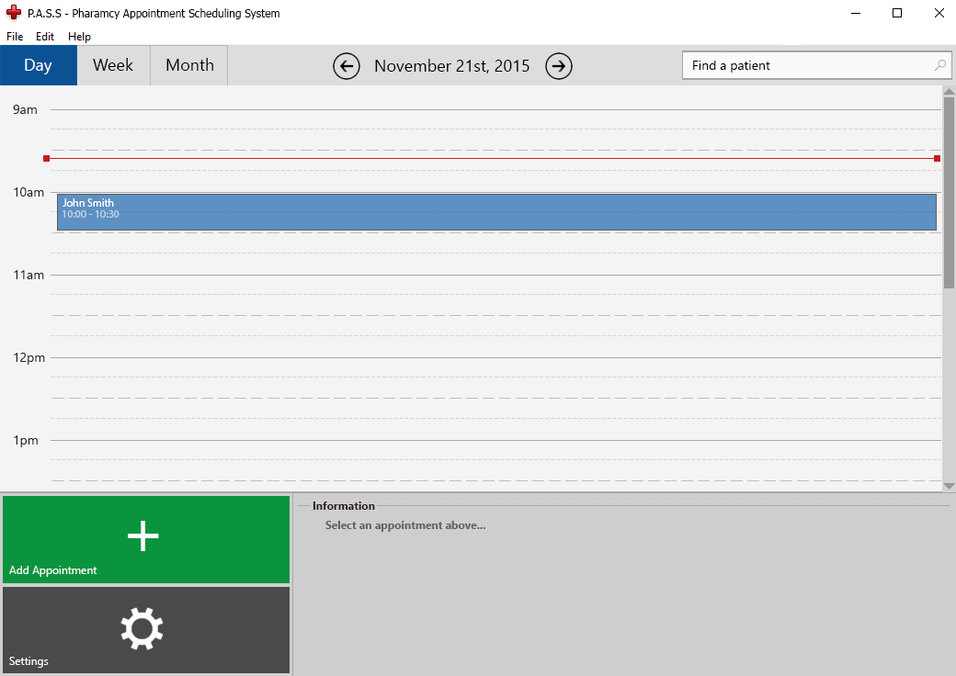

This is the default view presented to the user when the program is opened. PASS is built to be clear and easy to use for a new user. We chose to use large, clear buttons with relatable icons and colors corresponding to their functions. There is also a specific “flow” we kept in mind when designing this layout where the user generally works from the top of the screen down. The program can be broken down into four main “areas” detailed below:

**Top Bar:**



The top bar features a day/week/month choice that affects the calendar view below in the main window. The current date is displayed clearly in the middle, buttons on either side for easy navigation between days. To the right is the search function where staff can search for appointments by patient name.

**Calendar View:**

The default view here is the current day so that the user can quickly get an overview of the day ahead of them. As displayed above, appointments are shown a colored blocks that are clickable. Clicking on an appointment causes a change to the panel displayed below.

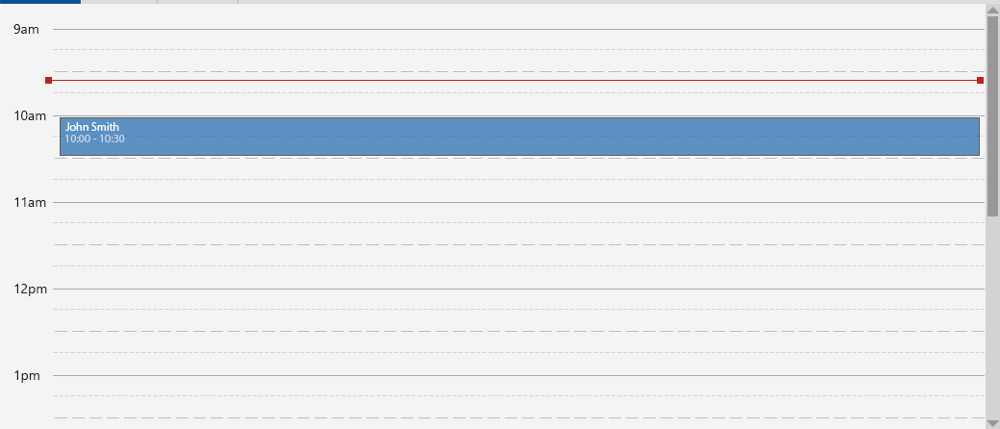

**Functions Area:**

Located in the bottom left corner, the buttons located here switch depending on whether or not an appointment is selected in the Calendar View. Functions include: Adding an appointment, editing an appointment, and deleting an appointment. Both views provide access to the settings menu, however the option to edit and delete an appointment only appear when an appointment is selected.

Appointment not selected:

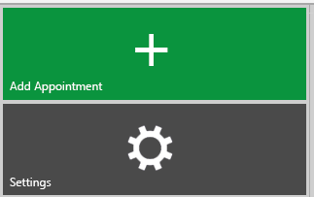

Appointment Selected:



**Information Area:**

The information bar will only show information on the selected appointment. If an appointment is not selected, the view provides an explanation of why information currently isn’t being displayed. This is shown by the “Select appointment above…” message seen below.

.

Appointment Not Selected:

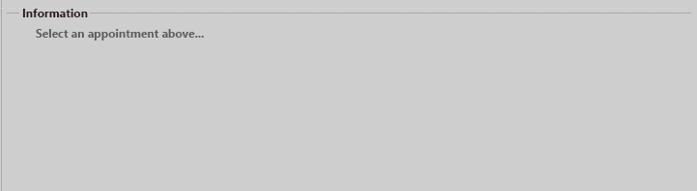

Appointment Selected:

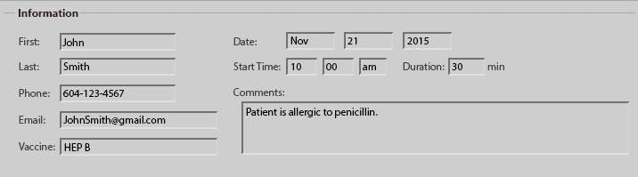

## **3.2 Storyboards**

**Adding an Appointment:**

To start the appointment creation. A staff member clicks on the “Add Appointment” button.



This prompts the user with a pop-up window to fill in the information for the appointment. The reason we use a pop-up window is to shift the attention from the main window to the task of adding an appointment to direct the focus of the user to the task currently underway. Email and Comments fields are provided, however they are optional. Once the necessary information has been entered, the user selects “Save” and the appointment is created and shown on the calendar view.

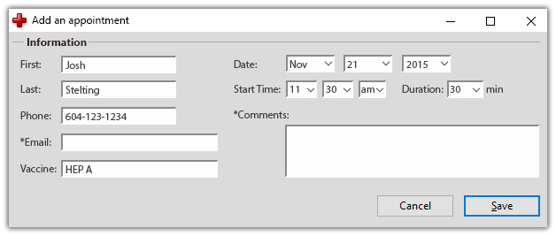

**Editing an Appointment:**

Before an appointment can be edited, it must be selected in the calendar view. Recall the view of the information bar where information is displayed. The information appears to be in greyed out text boxes that is not editable. This is by design to prevent accidental edits. The user then clicks the “Edit Appointment” button.



The greyed out boxes will now become white, indicating that they are editable.

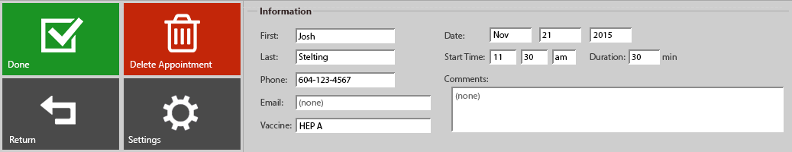

Information can be edited and will be saved only after the user clicks the “Done” button.

**Deleting an Appointment:**

An appointment must be selected before the user is given the option to delete it. If the user wishes to delete an appointment, they select the red “Delete Appointment” button.



They are then prompted with a confirmation pop-up window. This draws the attention of the user to the task they have selected and acts as an extra confirmation step so that the user does not accidentally delete an appointment.

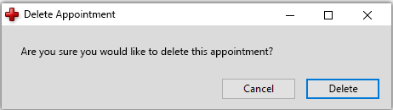

**Searching for an Appointment:**

Using the search area in the Top Bar, the user can search for an appointment. As the name is typed, a list of appointments will be shown alphabetically based on the patient’s name and what the user has entered so far.

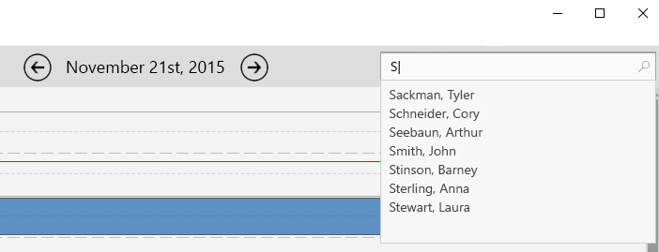

The user selects the name from the dropdown list and they are taken to the appointment in calendar view and the information is displayed in the information area below.

**Setting up Appointment Schedule:**

If the user selects the “Settings” button, they will be presented with a pop-up window:

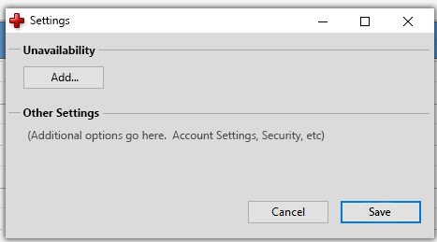

Next, under the “Unavailability” section, the user selects the “Add...” button and are taken to an additional window where they can define a timeframe that appointments cannot be scheduled.

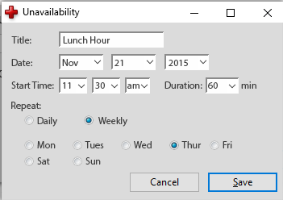

## **3.3 Sequence Diagrams**

The following figures are the sequence diagram of the System. It shows how system process the different actions and how these actions order.

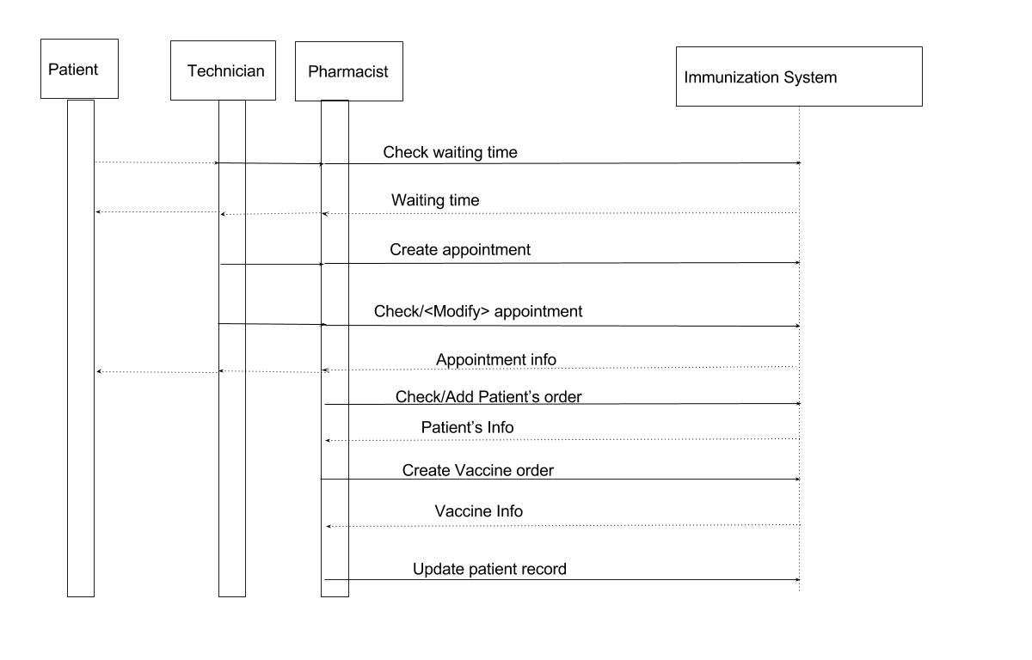

Sequence diagram of Immunization System

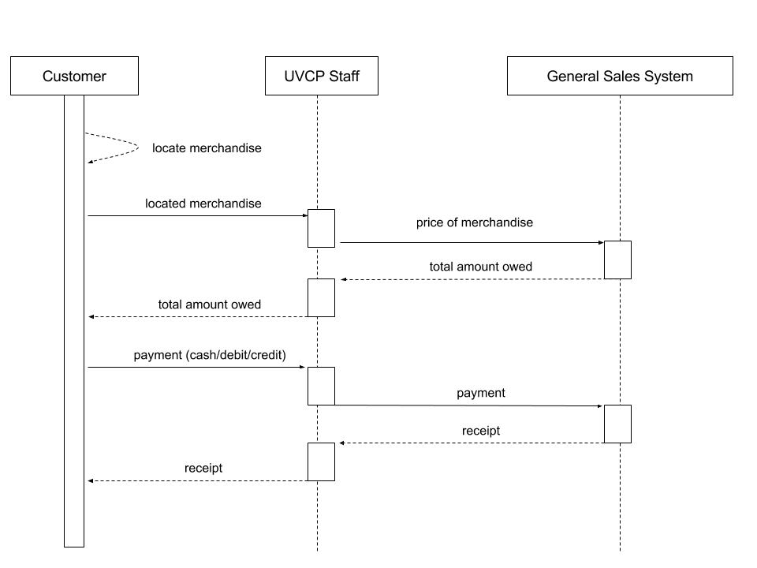

Sequence diagram of General Sale System

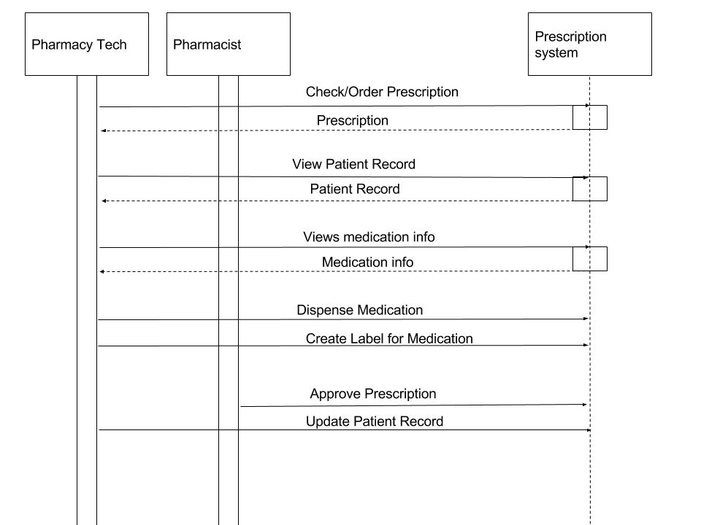

Sequence diagram of Prescription System

# **4.0 Conclusion & Recommendations**

## **4.1 Reflection on experience**

The project team had a clear understanding of the background, the problem, and the reasons for initiating the project. We involved stakeholders during the first client meeting to discuss the problem and identify the requirements, and the second client meeting to obtain feedback for our proposed solution. Moreover, a clear and feasible planning of project stages was achieved by holding on-going weekly meetings for general project updates and discussions for upcoming project deliverables. Clear division of tasks (e.g. each team member is responsible for writing up a section in the reporting documents) were discussed to ensure tasks were completed ahead of schedule with time for revision. In addition, the right choice of people for the team are facilitated so that the required skill is chosen to deliver each project deliverable. For example, the group member who was experienced in web design was assigned to create the web interface for our solution; group members who are good at public speaking would do our presentations; and group member who favoured writing would help write, revise, and enhance the reports.

The project team could have done better on facilitating communication between group members. Even though we had weekly meetings, we also used Google Hangouts as an online communication tool. Group members would sometimes experience a delay in receiving messages, and missed or were overloaded with messages, especially when there is an ongoing conversation in the chatting tool. Also, we could have held more meetings closer to the due dates of reports to gather everyone together for revisions instead of only having limited number of group members helping out. For our previous reports, only a few members reviewed and edited the report before finalization and submission. This caused stress among members who helped out, and the quality of report is not ensured. Furthermore, the team was not being motivated in terms of receiving timely feedback from individual members about their performance along the way for improvements. This is often due to miscommunication, misunderstanding, and false impression of members.

## **4.2 Recommendation for future students**

The following points are key recommendations for future students who will be taking CSC 375:

Project progress:

* Talk with the professor or TA in class by emailing, asking questions in class, and attending office hours;
* Involve stakeholders on every project stage for negotiation to ensure all customers’ needs are met;
* Fully understand the requirements and standards of the deliverables before the team starts working on it;
* Store all project deliverables in a common repository (Google Drive folder where everyone has access) and have someone to update and organize the documents regularly.

Communication:

* Choose agreed upon and appropriate communication tools among your teammates;
* Enhance communication between team members by giving timely feedback to other members for improvements and reaching out effectively to your team.

Project Management:

* Encourage collaboration on team work (e.g. everyone should participate in editing the work of others);
* Know every group member’s strengths and weaknesses, so their strengths are being harnessed;
* Motivate team members by acknowledging their contribution, having well-defined tasks for members to choose, show appreciation of their work, and give credits to their work.

Time management:

* Set up effective weekly meeting when you work as a group, and take the meeting minutes for every meeting;
* Manage time in an efficient way to make sure each group member’s tasks are completed on schedule with time for revisions.

# **5.0 Contributions**

Each member of the team contributed to the course work in the following ways.

|  |  |
| --- | --- |
| Alyssa Foote  *Project Manager* | Team leader, arranged and facilitated team meetings, presenter for project pitch, writer and editor for all team deliverables: RFP,Project Charter, SRS, Final Report, presenter for final Heart Pharmacy Transformation Project presentation |
| Justin Gill  *Business Analyst* | Point of contact for client (UVic Security), presenter for project pitch, writer and editor for all team deliverables: RFP,Project Charter, SRS, Final Report, presenter for final Heart Pharmacy Transformation Project presentation |
| Jenny Hu  *Project Analyst* | Writer for team meeting minutes, created project pitch slides, writer for all team deliverables: RFP,Project Charter, SRS, Final Report, presenter for final UVic Campus Security project presentation, |
| Alex Li  *Technical Analyst* | Presenter for project pitch presentation, writer for all team deliverables: RFP,Project Charter, SRS, Final Report, presenter for final UVic Campus Security project presentation |
| Sina Pinto  *Systems Analyst* | Writer and editor for all team deliverables: RFP,Project Charter, SRS, Final Report, composed final presentation slides |
| Josh Stelting  *Technical Analyst* | Coded and designed group website, presenter for project pitch, writer for all team deliverables: RFP,Project Charter, SRS, Final Report, designed prototype, presenter for final Heart Pharmacy Transformation Project presentation |
| Zhenyu Zhang  *Systems Analyst* | Writer for all team deliverables: RFP,Project Charter, SRS, Final Report, composed final presentation slides |

# **6.0 Appendices**

## **A. Glossary**

* **Bill** - The amount owed by the customer.
* **Customer** - Clients who purchase general products.
* **Event** - Immunization prescription, or general sales event.
* **Employee** - People employed by the company.
* **General Sales** **Event** - Sale of an item excluding prescription or immunization.
* **General Goods** - An item for sale excluding prescriptions or immunizations.
* **Immunization Event** - Includes pre-education, the vaccination and a 15 minute wait period in case of side effects.
* **Medication** - A substance used for medical treatment.
* **PASS -** Pharmacy Appointment Scheduling Software; simple user-friendly software that can be used to schedule appointments with a Pharmacist.
* **Patient** - Clients who receive prescription or immunization.
* **Pharmacist** - A licensed healthcare professional working in the pharmacy.
* **Pharmacy Technician** -A health care provider who performs [pharmacy](https://en.wikipedia.org/wiki/Pharmacy)-related functions, generally working under the direct supervision of a licensed pharmacist.
* **Prescription Event** - The event of filling a customer’s prescription.
* **Staff** - Pharmacist and Pharmacy Technician.
* **Stakeholders** - People or organizations actively involved in the project who may be affected by its outcome.
* **UVic** - University of Victoria (3800 Finnerty Rd. Victoria, BC, V8P5C2)
* **UVCP** - University of Victoria Campus Pharmacy, a location of Heart Pharmacy
* **Vaccine** - A substance used in the immunization process.

## **B. Interview Notes**

### i) First Client Meeting

**Requirements Elicitations for UVic Pharmacy System**

These are brief notes taken from our first requirements elicitation on October 1st, 2015. The meeting was started with brief introductions and the roles of the client. The following are the topics discussed.

**System Requirements:**

* Are there constraints on execution speed and response time?
  + Need to be able to accommodate patients AND immunization at the same time
  + Prioritize: don’t want immunization to be disturbed while serving walk-in clients
* Do you need the system at one location or several locations?
  + Only UVic Pharmacy
  + There’s only one computer and one cashier
* Is this system expected to interface with other systems currently in place?
  + Difficult right now → data is not in the same system
* Must access to the system or information be controlled?
  + Access controls:
    - Pharmacists: more system access, more info displayed about patient’s record
    - General public: access to their own information and prescriptions

**Users:**

* Will there be several types of users?
  + Employees at UVic pharmacy and the general public
* What is the skill level of each type of user including technical expertise?
  + Pharmacist (Store Manager)
    - Elder, moderate technical skills (don’t really want to learn new system), fills and approves prescription, provides immunization, take care of business needs (basically does everything)
  + Pharmacy Technician - cashier, fills prescriptions when pharmacist doesn’t have time
* What kind of training will be needed for each type of user?
  + Simple (as little as possible)
  + Duration of training: couple of hours
  + Funding is provided within the budget
* Would there be any issues with hiring another employee? Problems with payroll or enough work?
  + Don’t have money and space for another employee (physical space is too small)
* What would it take to get another staff member authorized to provide immunization?
  + Pharmacy Technician - up to him if he want to continue education (he is unqualified currently)
* When people comes in, what information be entered into the system currently?
  + Enter name, student number, phone number, health number

**Workflow:**

* What would be the ideal wait time for immunizations?
  + Ideal wait time: 5 to 10 minutes for normal hours
  + Current wait times for normal hours: 5 minutes
    - 6 to 8 people per hour (90% for filling prescriptions, 5% for immunization, 5% others)
  + Current wait time for busy hours: 30 minutes to 60 minutes
    - 20 to 25 people per hour (80% for filling prescriptions, 20% for immunization)
    - Busy hour include early morning and from 4pm to 6pm from Monday to Friday; and weekend is busier
* Workflow for filling prescriptions and workflow for immunization?
  + Patients come in with prescription
    - 15 to 20 minutes with prescription filled in normal hours; first come first serve basis in busier hours
  + Workflow for immunization
    - Patients comes in and takes a shot immediately, wait to take a shot, or check back later (walk-in basis, no system for booking immunization shots)
    - Total duration for one patient who takes a shot is about 30 minutes (6 to 7 minutes for questions, education and shot; then wait around 30 minutes to see if there are any side effects before going out the pharmacy)

**Other:**

* How much physical space will be taken up by the system?
  + Currently, there is only one computer and one cash register.
  + Best to load info on current computers
  + Don’t have money and space for new computers
* Is there a limit on the amount of $$ to be spent on development or on hardware and software?
  + Around $10,000.00
* Will there be any restrictions in place if we were to implement a real tracking wait time system?
  + As long as it doesn’t disturb workflow and wait time (automated calculations)
  + Interested
* Booking system is possible solution

### ii) Second Client Meeting

**2nd Client Meeting Elicitation Notes**

**General questions about the system**

* Is there a specific name for the system that you prefer?
  + P.A.S.S. is good!
* What operating system are you running on the current computer?
  + Windows 7
* Do you want the system as a web based site or an application software?
  + Web-based application: more costly (more security restrictions), saves time
    - Option 1: User can book appointment by themselves
    - Option 2: See the availability blocks
  + Software application: less costly, more secure
* Does staff have their own login credentials? Or do they need a new one?
  + Use current login name and password
* How far do you want to book the appointments in advance?
  + No restrictions to the system (up to the staff and the patient)
* Appointment booking
  + Staff book can help patients book the appointment by walk in request or telephone calls
  + If we implement a web-based application, patients can book the appointment by logging into the system on their own web browser.
* Once the time is passed and appointment didn’t occur,
  + Pop up and the appointment can be flagged as “Cancelled”

**Interface Design**

* Satisfied with the current look and feel of the system? YES
* Suggestions by Heart Pharmacy:
  + Color and coding the different vaccines (for storage and estimation purposes)
  + A window or pop-out indicating the patient’s more detailed information (e.g. vaccine history)
  + Statistic analysis
  + Replace * with “Optional” (when filling in the Add an appointment form)
  + Down time of the system: can be a message saying “Please call IT support” in the system interface
  + When booking an appointment, there’s a checkbox saying “Do you have a record for the pharmacy?” If yes, staff can pull up the record. If no, staff can build a new record.

**Functions**

* Any improvements on the current functions?
  + Connecting to the existing patient record system (costly, just a suggestion)
  + Alert and reminders (“there’s an upcoming appointment!”)
  + Flagging miss-appointments
* How well do you know about the prototype so far?
  + One of the easiest software application to learn
  + Very easy to navigate
* Can shifts overlap with each other?
  + Default: 30 minutes (can be adjusted by staff manually)

**Non-Functional Requirement**

* Can more than one user log in at a time?
  + Software application: No, because there’s only one computer in the pharmacy.

**Other questions**

* What do the employees do when the system goes down?
  + IT support, and wait until the system goes up again

* Who will fund this system?
  + Heart Pharmacy will fund the system
* Users
  + Web-based application: staff and patients (possible)
  + Software application: staff
* Workflow of staff
  + Save the time and space for patients and staff, because patients no longer have to wait
  + It takes the same time as if the patient walks in
* Budget
  + Current: $10,000 budget cost for developing the system
  + Add on: $5,000 for web based application (if needed)
* Training
  + 30 minutes (instructions, hands-on practice creating/deleting appointment and other necessary functions)
* Scheduling
  + By appointment - patients come in in scheduled appointment time
  + Walk ins - staff can help patient book appointment in front of the counter; or patients can wait until next available slot

## **C. Miscellaneous Materials**